Low Level Design

Project Code | Group 2
Project Name | Feedback Management System

Prepared / Modified by | Role | Date of preparation/ Modification
Sai Eshwar Myneni,  Abhishek Goyal | Designer | 18-Oct-2018
Reviewed by | Role | Date of review
Tanmaya K Acharya | Mentor
Approved by | Role | Date of Approval
Tanmaya K Acharya | Mentor
Circulation List | sai-eshwar.myneni@capgemini.com  rohit.b.agrawal@capgemini.com  abhishek.ay.kumar@capgemini.com  abhishek.b.goyal@capgemini.com  payyavula.bhavasagar@capgemini.com  snehasagari.bandarupalli@capgemini.com | Version Number : 1.0
Version number of the work product | Version 1.0

Table of Contents

1. Description Of The Unit 3
2. References 4
3. Dependencies / Assumptions 5
4. Class Diagrams 6
5. Sequence Diagrams 7
6. Design Components 8
6.1 List of UI Components…….………………………………………….…………………………………8
6.2 List of Design Classes…………………………………………………………………………………….10

7. Reusable Routines/Components……………………………………………………. 11
8. Messages 12
9. Configuration Files 13
10. Crud Matrix Table 14
11. Data Mapping Matrix 15
12. Action Flow Matrix 16
13. Stored Procedures 17
14. Program Specification / Pseudo Code 18
REVISION HISTORY OF THE WORK PRODUCT 21
Description Of The Unit

This project is aimed at developing a feedback management system for Data global solutions. The Training department of Data global solutions constantly conducts several training programs for the employees. Collection of feedback and analysis of feedback is a very critical part of any training program. This web application helps the training department to improve the training execution based on the analysis of feedback reports.
In this system we have design three forms participant login form, Training Admin login form, Training coordinators login form will login in their login form with proper id and password.
The following are the functionalities performed by the different users
- Training Admin
- Maintain the skill set of faculties
- Maintain the Training courses
- View the feedback reports and feedback defaulters report
- Training Coordinators
- Creation/modification/deletion of the Training Programs
- View the feedback reports and feedback defaulters report
- Participants
- Enter feedback for the training programs attended
Feedback data is collected from the participants to understand the positives and improvement areas of the training. Following are the parameters should be rated by the participants
- Presentation and communication skills of faculty
- Ability to clarify doubts and explain difficult points
- Time management in completing the contents
- Handout provided (Student Guide)
- Hardware, software and network availability

- Rating Terminology
- 5-Excellent: Ideal way of doing it
- 4-Good: No pain areas or concern but could have been better
- 3-Average: There are concerns but not significant
- 2-Below Average: Needs improvement and is salvageable
- 1-Poor: This way of doing things must change

References

Reference | Description
Repository reference | https://github.com/SaiEshwar157233/FeedbackMS
Class Diagram | \Feedback_managment_PLP Documents\ProjectDocuments\DesignDocuments\HLD\Class Diagram
URS
UTP
DB Design | \FMS_Git\Feedback_managment_PLP Documents\ProjectDocuments\DesignDocuments\HLD\DB Design

Dependencies / Assumptions
Dependencies:
The user (participant, coordinator, training admin) should be logged in.
All fields in Feedback page are filled correctly.

Assumptions:
The Admin details are stored in the database.
The Feedback Information will get store in the database.

Class Diagrams
Class Diagram

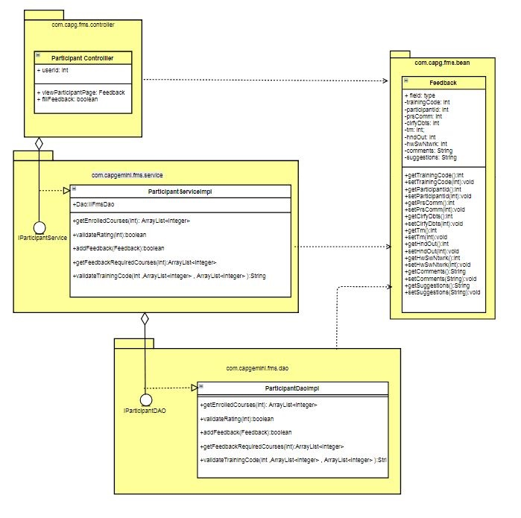

Sequence Diagrams

Sequence Diagram

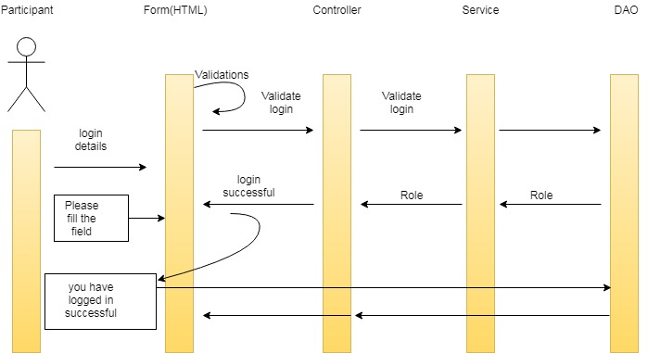

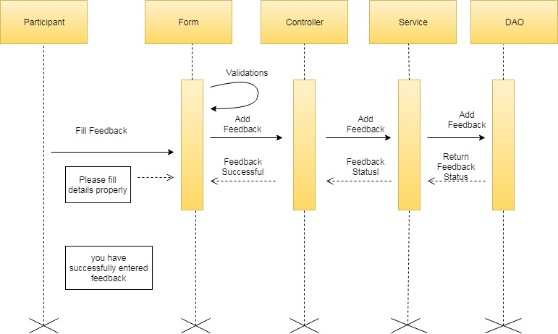

Design Components

List Of UI Components
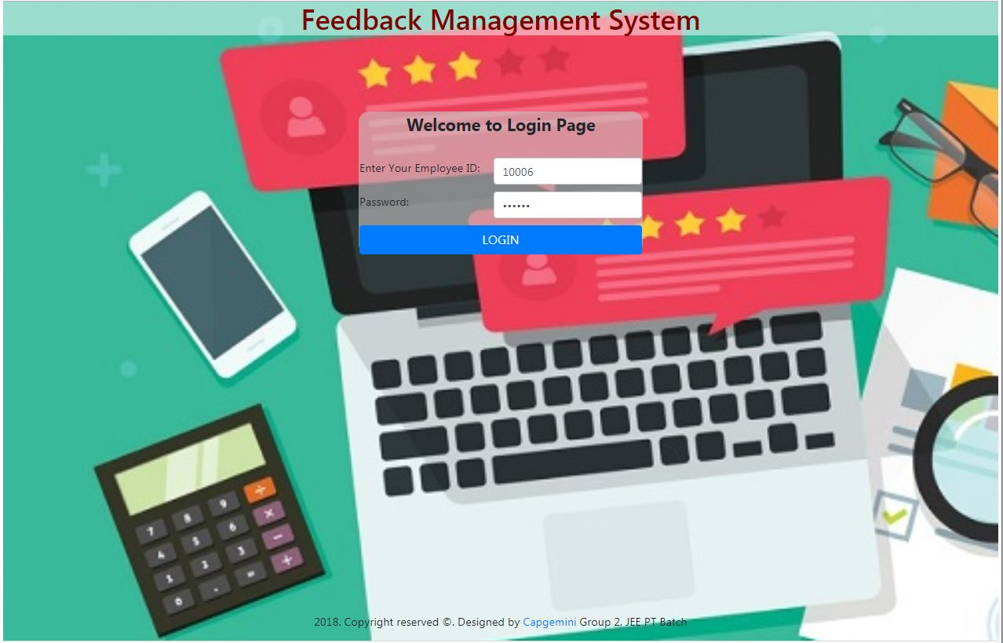

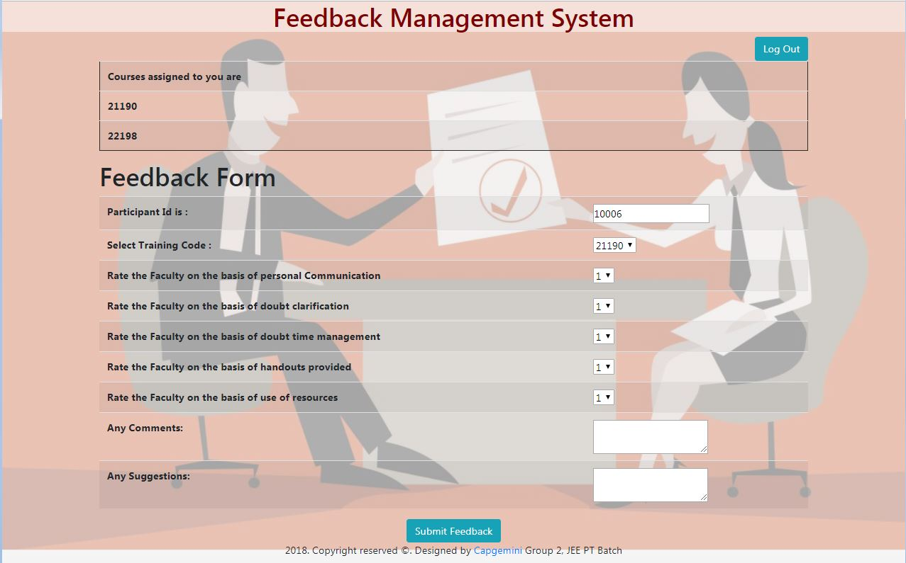

Sr. No. | LLD Name | Class Name | Method Name | Method Description
1 | Insert Feedback  Module | FeedbackDTO | Appropriate getters and setters methods | Getters retrieve the property values and setters set the property values
2 | Insert Feedback  Module | ParticipantController | Public boolean | Sets the model attribute.  Calls the Service layer method to insert the Feedback details in to the database
3 | Insert Feedback  Module | ParticipantServiceImpl | public boolean insertFlight(FlightInformationBean flightInfo)throws AirlineException | Calls the DAO layer method to insert the Feedback details in to the database
4 | Insert Feedback  Module | ParticipantDaoImpl | public boolean insertFlight(FlightInformationBean flightInfo) throws AirlineException ) | Inserts the Feedback information into the database and returns the result to ParticipantServiceImpl

List Of Design Classes

Re-Usable Routines/Components
Re-Usable Routines/Components

- CSS files.
- View Feedback Module.

Messages

#. | Type | Message Text
M1 | Error | Password should not be empty.
M2 | Error | Invalid credentials please try again.
M3 | Error | Please enter password

Configuration Files

File Name | Path | Description
oracle.properties |  | To configure database connection.
Web.xml |  | To configure the bean properties.
Dispatcher-servlet.xml |  | To configure the request mapping and view resolver.

Crud Matrix Table

# | Table Name | Create | Read | Update | Delete
1 | Feedback_Master | Y | Y | Y | Y

Data Mapping Matrix
Sr. No. | Screen Label | Field Source | Field Type | Data Type | Max Length | Data Flow | Mandatory
1 | Login  (UserID,password) | com.capgemini.fms.bean.EmployeeDTO | Text Box | Integer,  String | 5,30 | UI→D | Yes
2 | PrsComm | com.capgemini.fms.bean.FeedbackDTO.prsComm | Dropdown Box | String | NA | UI→D | Yes
3 | Doubts clarification | com.capgemini.fms.bean.FeedbackDTO. ClrfyDbts | Dropdown Box | String | NA | UI→D | Yes
4 | Time Management | com.capgemini.fms.bean.FeedbackDTO.Tm | Dropdown Box | Local Date | NA | UI→D | Yes
5 | Hand Outs | com.capgemini.fms.bean.FeedbackDTO.HndOut | Dropdown Box | Local  Date | NA | UI→D | Yes
6 | Hardware Software and  Networking | com.capgemini.fms.bean.FeedbackDTO.hwSwNtwrk | Dropdown Box | String | 4 | UI→D | Yes
7 | comments | com.capgemini.fms.bean.FeedbackDTO. comments | Text Box | String | 4 | UI→D | Yes
8 | suggestions | com.capgemini.fms.bean.FeedbackDTO. suggestions | Text Box | int | 2 | UI→D | Yes

Legend

UI (User Interface Only)
UI → D (User Interface to Database)

Action Flow Matrix

Sr. No. | Action | Description | Process
1 | On Login open web page to add feedback. | Redirected to the Insert Feedback form | The Participant clicks on the Login in Home page and gets redirected to the Insert Feedback form.
2 | On click of Submit button in Insert Feedback Form | The feedback information is inserted into the database. | Data is entered in the fields by the Participant which gets inserted into the database when Submit button is pressed.

Stored Procedures

# | Stored Procedure Name  (with Description) | Input/Out Parameters | Type | Size
1. | NA

Program Specification / Pseudo Code

<ACTION: ENTER_FEEDBACK >

Pseudo Code:
- Client Side Scripting:
None

- Server Side Scripting:
BEGIN
Call the Service Layer for inserting the Feedback details into the database.
END

Pseudo Code:
14.2 <ACTION: RAISE_REQUISITION >

- Server Side Scripting:
IF Login is Empty
Print Error Message M1
ELSE IF password is not given in
Print Error Message M2

- Server Side Scripting:
BEGIN
Call addFlightDetailsAction (@ModelAttribute (“insertFlight") @Valid FlightInformationBean insertFlight, BindingResult result, Model model) in Controller class in Presentation Layer
BEGIN
Call insertFlight (FlightInformationBean insertFlight) in AdminServicempl class in Service Layer
BEGIN
Call insertFlight (FlightInformationBean insertFlight) in class AirlineDaoImpl in Data Access Layer
BEGIN
Create query for inserting flight details into FlightInformation table
Return String value.
END
Return String value to Service Layer
END
Return String value to Presentation Layer

END
IF successful then navigate to AdminSuccess page and show success message.
Else navigate to Error page and show error.
END

REVISION HISTORY OF THE WORK PRODUCT
<To be maintained by projects>

# | Date | Version # | Section Changed | Details of changes made | Approved By
1
2

